LAB 04 PRACTICE

Figure 1. Build a form like this one (name it **emailList.jsp**) (30pts)

<html>

<head>

<meta http-equiv="Content-Type" content="text/html; charset=UTF-8">

<title>Page</title>

<style>

.form-item {

display: flex;

align-items: center;

margin-bottom: 10px;

}

.form-item label {

min-width: 180px;

margin-right: 10px;

}

input[type="text"],

input[type="email"],

select,

textarea {

width: 30%;

margin-bottom: 5px;

}

.buttons {

gap: 2rem;

display: flex;

align-items: center;

margin-bottom: 10px;

}

</style>

</head>

<h2>Collect three Parameters </h2>

<form method ="post" action="./GetThreeParam">

<div class="form-item">

<label for="first">Email:</label>

<input type="text" id="first" name="first" required />

</div>

<div class="form-item">

<label for="second">First Name:</label>

<input type="text" id="second" name="second" required />

</div>

<div class="form-item">

<label for="third">Last Name:</label>

<input type="text" id="third" name="third" required />

</div>

<div class="form-item buttons">

<input type="submit" value="Join Now" />

</div>

</form>

</html>

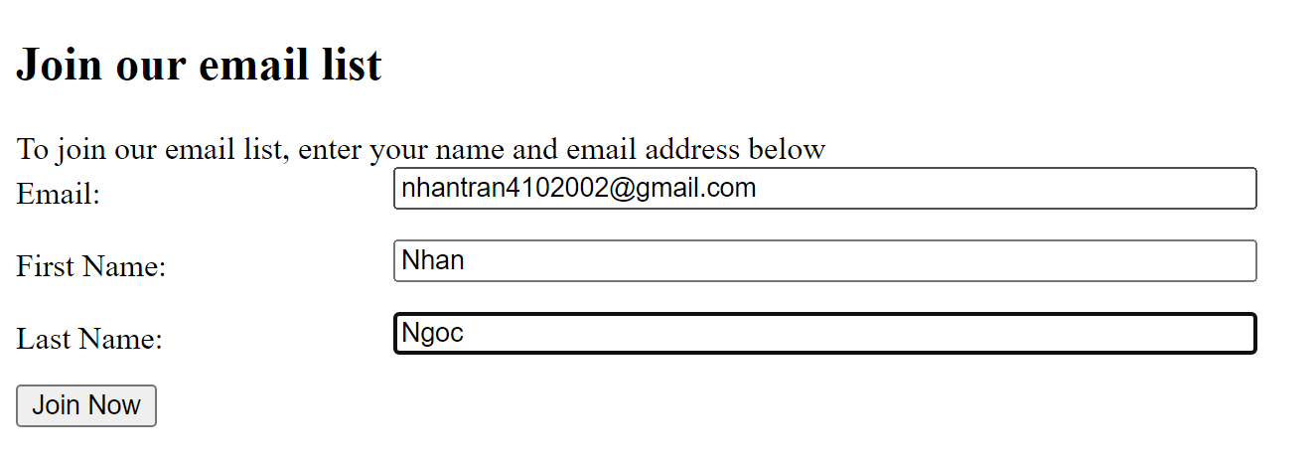

Figure 2. Sample input form.

Figure 3. When you click submit. It send you to **EmailServlet.java** (35pts) Return button will send you to jsp page to enter another email.(10pts)

public class EmailServlet extends HttpServlet {

@Override

protected void doGet(HttpServletRequest request, HttpServletResponse response)

throws ServletException, IOException {

response.setContentType("text/html;charset=UTF-8");

try (PrintWriter out = response.getWriter()) {

out.println("<h1>Hello Tran Ngoc Nhan ITITIU20264</h1>");

}

}

@Override

protected void doPost(HttpServletRequest request, HttpServletResponse response)

throws ServletException, IOException {

response.setContentType("text/html;charset=UTF-8");

String email = request.getParameter("email");

String firstName = request.getParameter("firstName");

String lastName = request.getParameter("lastName");

try (PrintWriter out = response.getWriter()) {

out.println("<!DOCTYPE html>");

out.println("<html>");

out.println("<head>");

out.println("<title>Reading three request parameters</title>");

out.println("</head>");

out.println("<body>");

out.println("<style>");

out.println("h1 {"); // note leading brace

out.println("color:orange;");

out.println("background-color:blue;");

out.println("text-align: center;");

out.println("}");

out.println("</style>");

out.println("<h1>Thanks for joining our email list </h1>");

out.println("<span>Here is the information that you entered: </span>");

out.println("<li>Email :" + email + "</li>");

out.println("<li>First Name :" + firstName + "</li>");

out.println("<li>Last Name :" + lastName + "</li>");

out.println("<span>To enter another email address, click on the Back button on your browser or the Return button show below </span>");

out.println("<input type=\"button\" value=\"Return\" onclick=\"window.location.href='cancel'\"/>" +

" </div>");

out.println("</body>");

out.println("</html>");

}

}

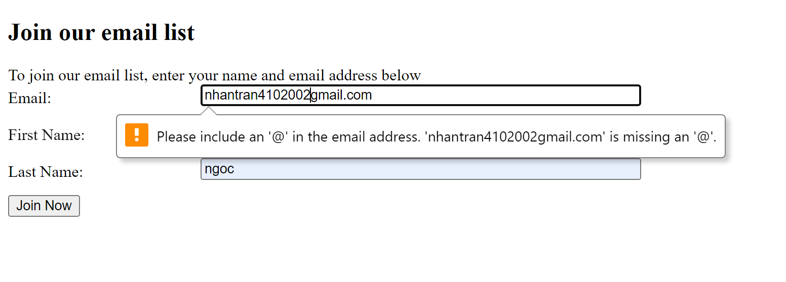

Figure 4. The form also needs to validate the email (10pts)

Write a ***style.css*** file to decorate your work. (15pts)

<style>

.form-item {

display: flex;

align-items: center;

margin-bottom: 10px;

}

.form-item label {

min-width: 180px;

margin-right: 10px;

}

.desc {

padding-bottom: 20px;

margin-top: 10px;

}

input[type="text"],

input[type="email"],

select,

textarea {

width: 30%;

margin-bottom: 5px;

}

.buttons {

gap: 2rem;

display: flex;

align-items: center;

margin-bottom: 10px;

}

</style>

1. Name the pdf file as <studentName><ID><lab04_pactice>
2. Zip (rar) the project directory.
3. Submit PDF and zip to the BB.